PHASE 3 (Weeks 4–5): Architecture & Master Schema
Your deliverable consists of three technical artifacts and a one-page architecture justification:
Architecture diagram (.drawio) — shows the central master database, source systems, staging layer, and data flows.
Entity Relationship Diagram (ERD) — shows tables, primary keys, foreign keys, and relationships.
MySQL schema (schema.sql) — creates the clinics, staff, patient master, source links, visits, and billing tables.
One-page architecture justification — explains why hub-and-spoke is preferable to fully centralized or decentralized architecture for this healthcare system.

1. Architecture decision and justification
The recommended architecture is hub-and-spoke with staging. The source systems remain the spokes, while a central master database acts as the authoritative destination for integrated patient data.
Source systems (spokes)
Legacy A · Legacy B · Pharmacy POS · Paper scans
Extract data from source systems
Staging and data quality
Validate · Standardize · Detect duplicates · Reconcile
Approved and reconciled records
Central master database (hub)
m_patient · patient_source_links · Clinics · Staff
Controlled access and authorized data exchange
Operational use
Clinic visits · Clinical workflows · Billing · Reporting
The diagram represents the proposed logical architecture. In implementation, source data should first enter staging tables or a staging database, where validation, matching, and reconciliation occur before approved data is loaded into the master database.
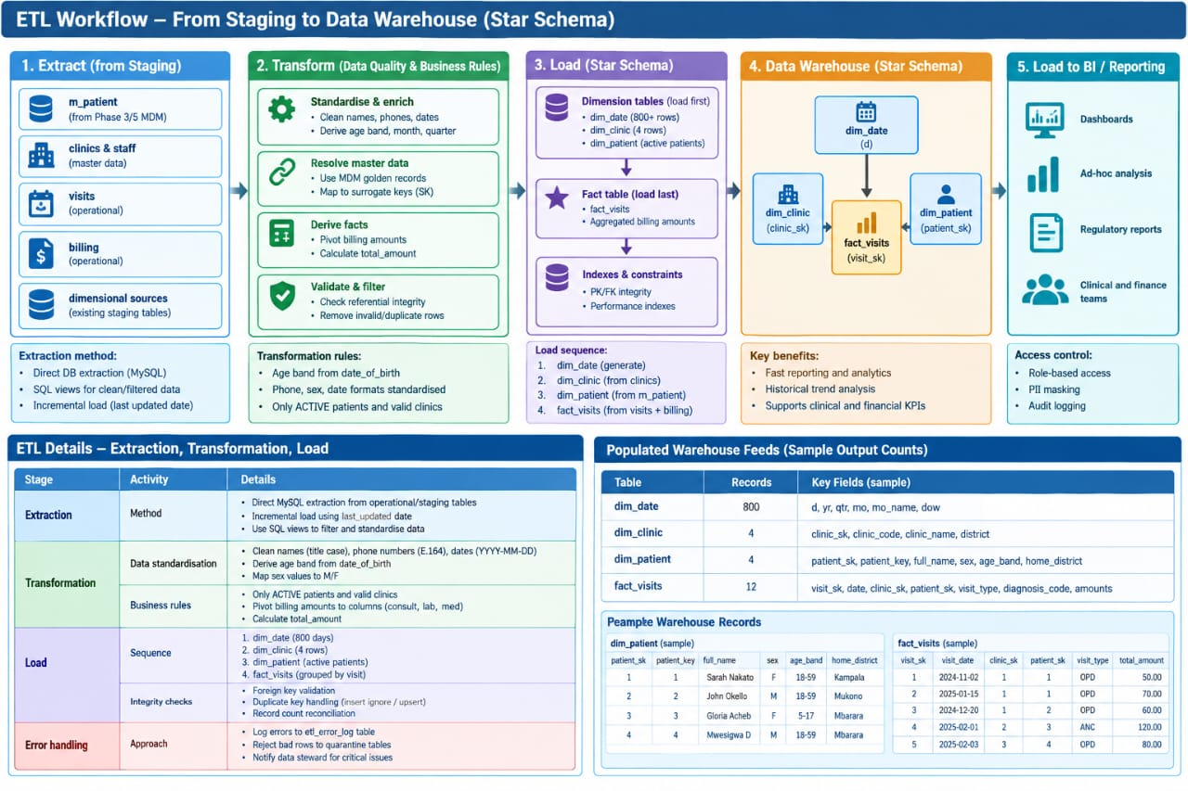

2. Download your Phase 3 deliverables
Architecture diagram + ERD
Editable draw.io file containing two pages: the architecture and entity relationship diagram.
Download the draw.io diagrams
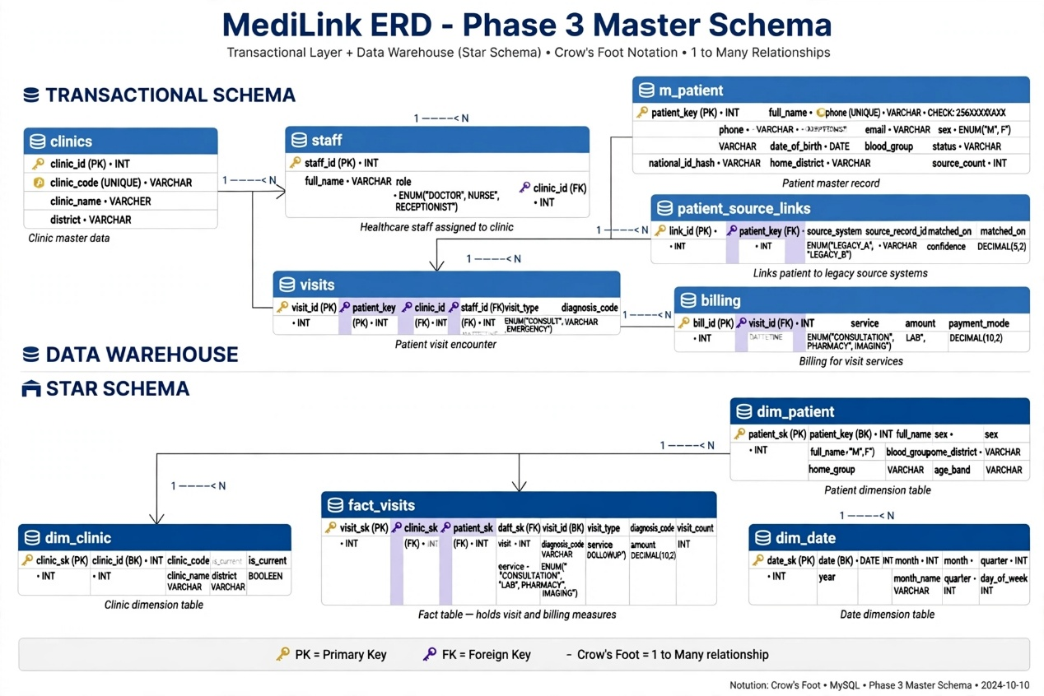
MySQL master schema
SQL script for all six tables, primary and foreign keys, constraints, clinic seed data, and verification queries.
Download schema.sql
Architecture justification
Word document comparing hub-and-spoke with centralized and decentralized architectures, including benefits, limitations, and design controls.

Decision: Hub-and-Spoke with central master database `medilink` as Hub, source systems as Spokes feeding via Staging Layer.

Proposed Logical Architecture:
Source Systems (Spokes) -> Staging Layer (stg_legacy_a, stg_legacy_b) [Validation, Matching, Reconciliation, DQ Check] -> Master Database Hub (m_patient golden, clinics, staff, visits, billing, patient_source_links) -> Data Warehouse (dim__, fact_visits) -> BI Layer (MoH Report)

This enforces the rule: _No source data enters master without validation in staging.

Comparison Matrix:
Criteria | Centralized | Decentralized | Hub-and-Spoke (Chosen)
How it works | One DB replaces all 4 clinics immediately | Each clinic keeps own DB, no central truth | Central hub medilink is golden, spokes keep operating and feed staging
Patient Identity | Solves duplicate but forces big-bang migration | Fails - Sarah Nakato stays 3 times, no one knows real count | Solves - Phone 256XXXXXXXXX match in staging -> 1 golden in m_patient + crosswalk
Autonomy | Low - Clinics in Gulu with poor internet cannot work offline | High - but no consolidation for MoH | Balanced - Clinics keep POS/paper, sync to hub later
Risk & Cost | Very High Risk - must shut down Legacy A/B, data loss, staff retraining in 1 week. Cost high upfront | Low upfront but High ongoing cost - 3 staff take 2 weeks to compile MoH report manually forever | Low-Medium Risk - Phased. Staging catches errors. Hub built in 2 weeks while clinics operate
Data Quality | Clean after migration but no staging check | No check - 6 sex values, phone 0 enters | Best - Staging enforces CHECK phone REGEXP '^256[0-9]{9}\$', ENUM M/F, review queue for conflicts
DPA Compliance | Central helps but breach risk during big-bang email migration | Fails - No control, nurse emailed HIV spreadsheet to wrong person | Best - Hash NID at staging (SHA2), masking views, audit triggers in hub
MoH Reporting | Fast after migration | Fails - Manual 2 weeks, error prone | Fast - ETL pivots billing to fact_visits, ROLLUP query returns in ms
Scalability | Hard to add 5th clinic | Easy to add but increases silos | Easy - New clinic = new spoke -> register in data_lineage catalog before trusted (Rule 9)

Justification:

1. Centralized Rejected: MediLink has 4 independent systems plus one paper-based branch in Gulu. Centralized requires immediate shutdown of Legacy A (MySQL 5.1) and Legacy B (online booking). This would stop clinical workflows (OPD, Billing) and cause data loss. It also fails to handle paper scans. Business cannot afford 2-week clinic closure.

2. Decentralized Rejected: This is the CURRENT problem. It leaves duplicates, no golden record, no enforcement of phone completeness target ≥97%, and violates Uganda DPA because NID is in plaintext in Legacy A. MoH report will continue to take 3 staff 2 weeks. No governance possible.

3. Hub-and-Spoke Chosen: It provides,

Operational Continuity: Source systems continue as Spokes. Data first lands in staging where systematic cleansing happens (Title Case names, `0772 -> 256` normalization, NULL for `0`).

Single Truth: Hub holds `m_patient` with `source_count` and `patient_source_links` to prove lineage. Survivorship: contact = latest-wins, identity = never auto-merge -> `mdm_review_queue`.

Governance Enforcement: Technical controls live in hub: `chk_phone` constraint, `trg_billing_immutable`, RBAC roles.

Future-proof: To add a 5th clinic, only requirement per Business Rule 9 is to register metadata in catalog (`glossary`, `data_lineage`) before trusted. This supports Data Mesh later (each clinic as domain).

Therefore Hub-and-Spoke delivers the complete lifecycle: Inventory -> Governance -> Clean Master -> Warehouse -> Compliance -> Reporting, which centralized and decentralized cannot deliver in a merged network with dirty, distributed sources.

